Anani Vossah

May 4th, 2023

Assignment 8.1 Discussion:

Provide two examples of Inner joins. For your examples, show the contents of each table, then show the results of the join. Would any other SQL statement provide the same results? If so, include it in your response.

SELECT film.film_id, film.film_name, genre.genre_name, film.film_releaseDate, film.film_runtime, genre.genre_id

FROM movies.film

LEFT JOIN movies.genre ON film.genre_id = genre.genre_id

order by film.film_name;

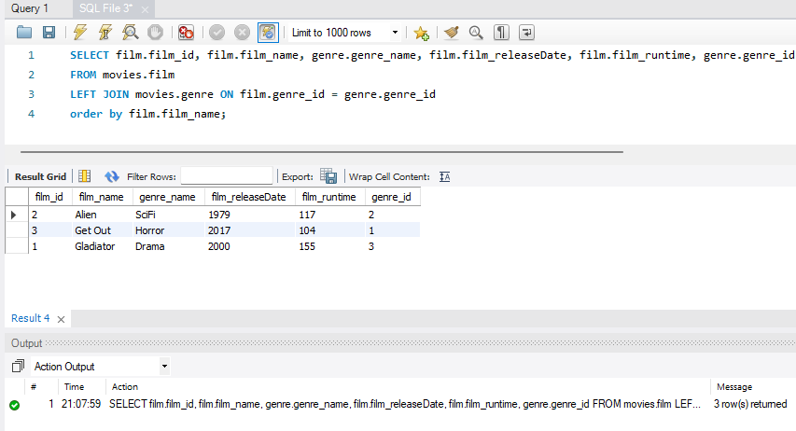

SELECT *

FROM movies.film

FULL JOIN movies.genre;

